MANUAL PROCESS

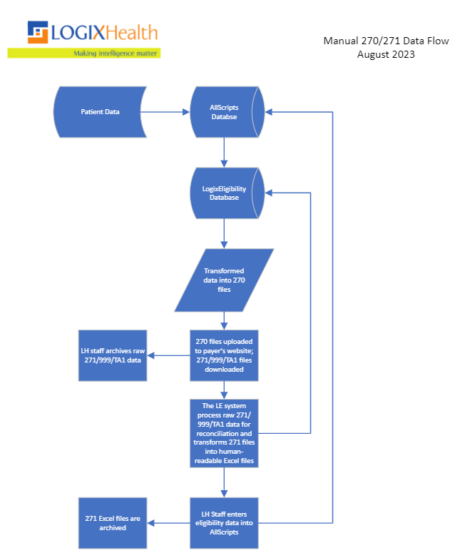

1. Patient data is imported into the AllScripts database after medical services have been rendered.
2. Patient data is imported into the LogixEligibility database from the AllScripts database.
3. 270 files are generated by the LogixEligibility application based on patient data; dates of service, schedules, and file types
   1. Self-pay = no member ID present
   2. Insurance = Member ID present
4. Once the 270 files have been generated, an analyst will log onto the Payer's website and upload all available 270 files for that day.
5. The analyst will also download the 271, 999 and TA1 responses (when applicable) from the previous business day.
6. The raw 271 files will be dropped into a specified folder location, and our LogixEligibility application will process those raw 271 files into human readable Excel files.
   1. The data within the raw 271 files will be stored in our LogixEligibility database in order for users to run reports.
   2. The LogixEligibility application will also use the raw 271 files to reconcile files within the application so that users can determine if all expected files have been returned successfully.
7. The 271 human-readable Excel files are sent to our data entry team so that they can manually enter eligibility data into AllScripts.
   1. Data includes whether a patient has Active coverage or Inactive coverage.

SFTP PROCESS

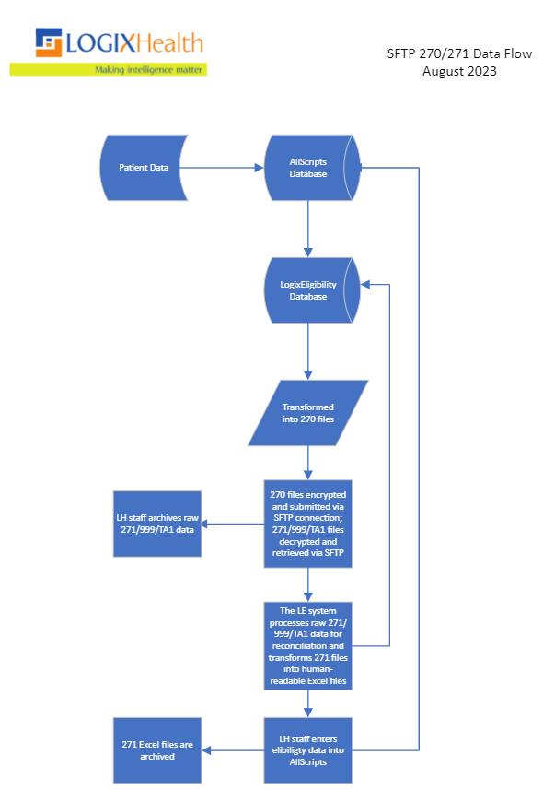

1. Patient data is imported into the AllScripts database after medical services have been rendered.
2. Patient data is imported into the LogixEligibility database from the AllScripts database.
3. 270 files are generated by the LogixEligibility application based on patient data; dates of service, schedules, and file types
   1. Self-pay = no member ID present
   2. Insurance = Member ID present
4. The 270 files are placed by the LE application in the respective payer's SFTP folder location.
5. The SFTP submission process is on a schedule, and that schedule will encrypt our 270 files, and then push our 270 files to the payer's inbound mailbox.
6. Our SFTP process will then pull our 271, 999 and TA1 reports (when applicable) from the Payer's outbound mailbox and decrypt those files.
7. An EDI analyst will collect all responses from the SFTP folder for each payer.
8. The raw 271 files will be dropped into a specified folder location, and our LogixEligibility application will process those raw 271 files into human readable Excel files.
   1. The data within the raw 271 files will be stored in our LogixEligibility database in order for users to run reports.
   2. The LogixEligibility application will also use the raw 271 files to reconcile files within the application so that users can determine if all expected files have been returned successfully.
9. The 271 human-readable Excel files are sent to our data entry team so that they can manually enter eligibility data into AllScripts.
   1. Data includes whether a patient has Active coverage or Inactive coverage.

SOAP PROCESS

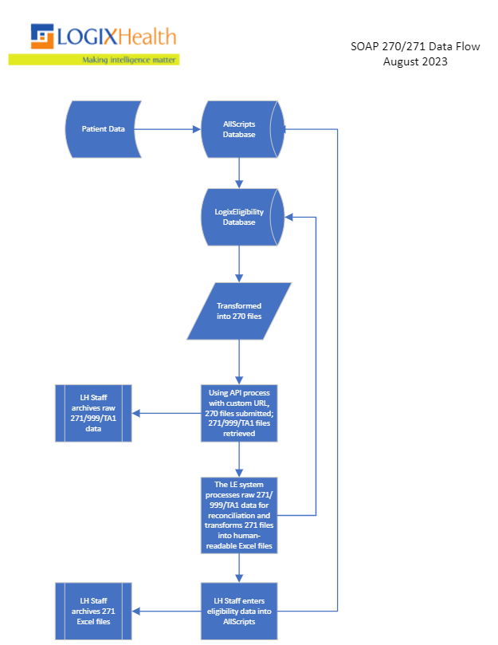

1. Patient data is imported into the AllScripts database after medical services have been rendered.
2. Patient data is imported into the LogixEligibility database from the AllScripts database.
3. 270 files are generated by the LogixEligibility application based on patient data; dates of service, schedules and file types
   1. Self-pay = no member ID present
   2. Insurance = Member ID present
4. The 270 files are placed by the LE application in the respective payer's SOAP folder location.
5. Using a URL-based application, the analyst team will submit the 270 files to the payer
   1. The SOAP process is an XML-based format the converts the 270 X12 files into XML and submits each voucher in a real-time format.
   2. The SOAP process will retrieve the 271 XML response, convert that to the X12 format.
6. An EDI analyst will collect all responses from the SOAP folder for each payer.
7. The raw 271 files will be dropped into a specified folder location, and our LogixEligibility application will process those raw 271 files into human readable Excel files.
   1. The data within the raw 271 files will be stored in our LogixEligibility database in order for users to run reports.
   2. The LogixEligibility application will also use the raw 271 files to reconcile files within the application so that users can determine if all expected files have been returned successfully.
8. The 271 human-readable Excel files are sent to our data entry team so that they can manually enter eligibility data into AllScripts.
   1. Data includes whether a patient has Active coverage or Inactive coverage.